Working With Dataset

# Maximum Heart Rate In Existing Heart Disease By Exercise Angina

|  |  |
| --- | --- |
| Team ID | PNT2022TMID04535 |
| Project Name | Visualizing and Predicting Heart Diseases with an Interactive Dashboard |

## Visualization:

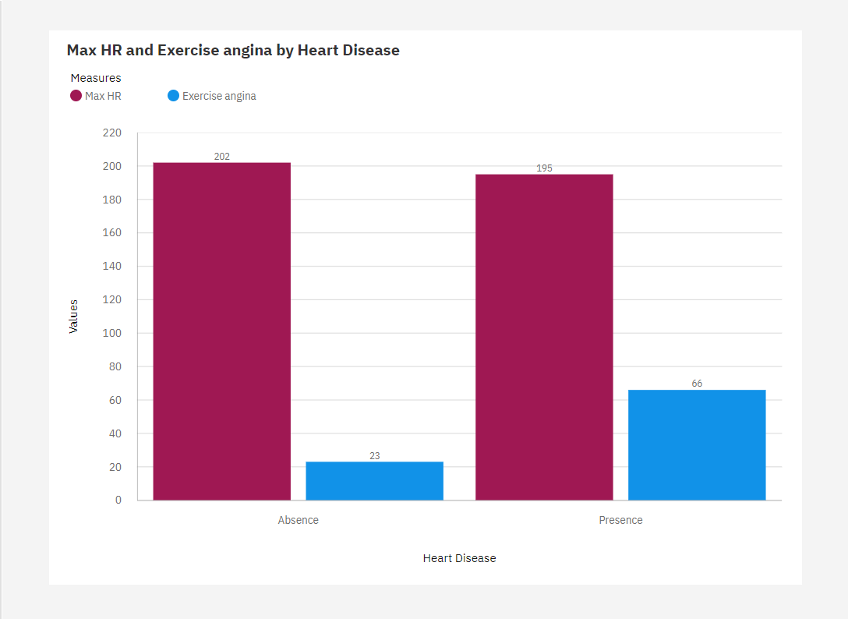

1. The largest value of **Max HR** is 202, occurring when **Heart Disease** is Absence.
2. **Exercise angina** ranges from 23, when **Heart Disease** is Absence, to 66, when **Heart Disease** is Presence.
3. Over all **heart diseases**, the average of **Exercise angina** is 0.3296.
4. The most common value of Heart Disease is Absence, occurring 150 times, which is 55.6 % of the total.